**Fuji Film / DBL**

**King & Wood Mallesons**

**User Guide**

February 2025



**Revision History**

|  |  |  |  |
| --- | --- | --- | --- |
| **Date** | **Version** | **Description** | **Author** |
| 12th Feb 2025 | 1.0 | Initial Version | AL |
|  |  |  |  |
|  |  |  |  |
|  |  |  |  |
|  |  |  |  |
|  |  |  |  |

Table of Contents

1. Introduction 4

1.1 Purpose 4

1.2 Scope 4

2. Downloading & Installing the Digital Hub Mobile Application 5

3. Initial Setup of the Application 5

3.1 If you already have an account 5

4. Data Set Up in the Application 9

4.1 Client Settings 9

4.2 Scan Setting 11

5. How to Process Booking that are Allocated to You 13

6. How to Scan Run 17

7. How to mark POD (Proof of Delivery) 20

# Introduction

The **Digital Hub Mobile Application** is a powerful tool designed to streamline courier operations by providing users with a seamless way to manage bookings, scan runs, and update delivery statuses in real time. This guide serves as a comprehensive resource for users to understand the app’s features, functionalities, and workflows, ensuring efficient and accurate processing of courier jobs.

* 1. Purpose

The purpose of the document is to give user a step-by-step guide on how to access the following functions using DHL:

* International Booking
  1. Scope

The scope of this document will be limited to the specific functionality made available to King and Wood Hub Admins who will use the system to book international documents and parcels using DHL as a carrier.

# Downloading & Installing the Digital Hub Mobile Application

Click on below link to download the Digital Hub Mobile Application for KWM

[**Digital Hub Mobile Application for KWM Live**](https://drive.google.com/file/d/1kezVUZBLdps2zChXGwo3-zdS_0aBGs3z/view?usp=drive_link)

Download and install the APK.

# Initial Setup of the Application

Open the Digital Hub app & click on **Log in.**

* 1. If you already have an account

Enter your **Driver ID**, and click on **Submit** button.

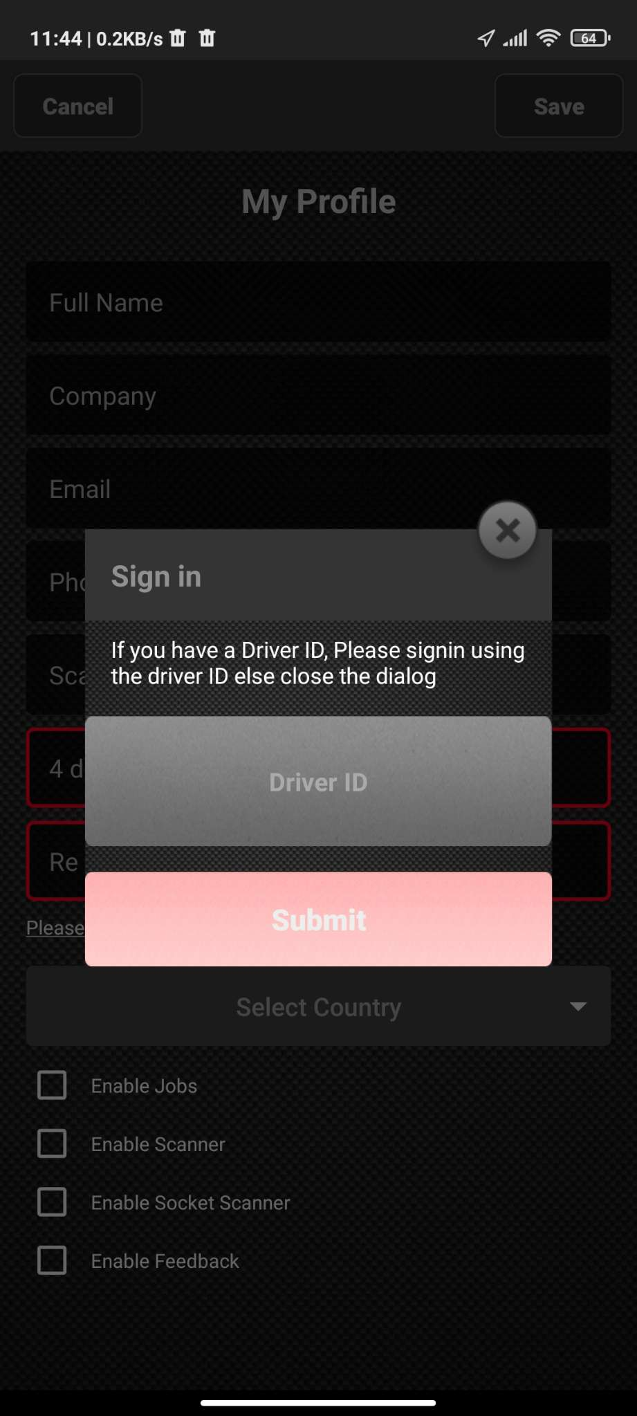

Your personal details will be automatically updated.

Please enter the **Scan Run ID**, and a **4 Digit Security Pin** which will be used to login to the app later.

And choose your country from the dropdown list as well.

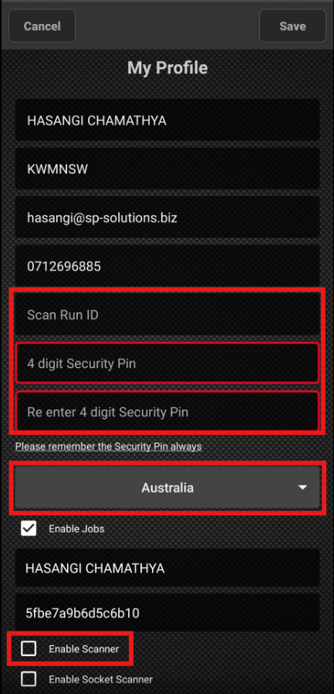

Click on **“Enable Scanner”** check box and make sure it is **ticked**.

Then click on the **Save** button on top of the user interface.

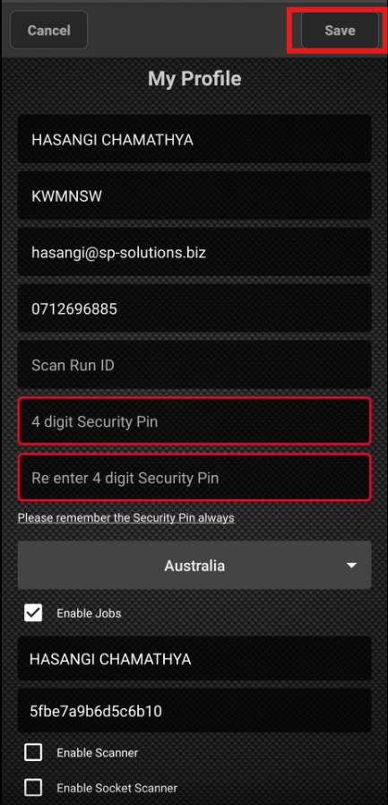

Below message will be shown once the initial registration is successful.

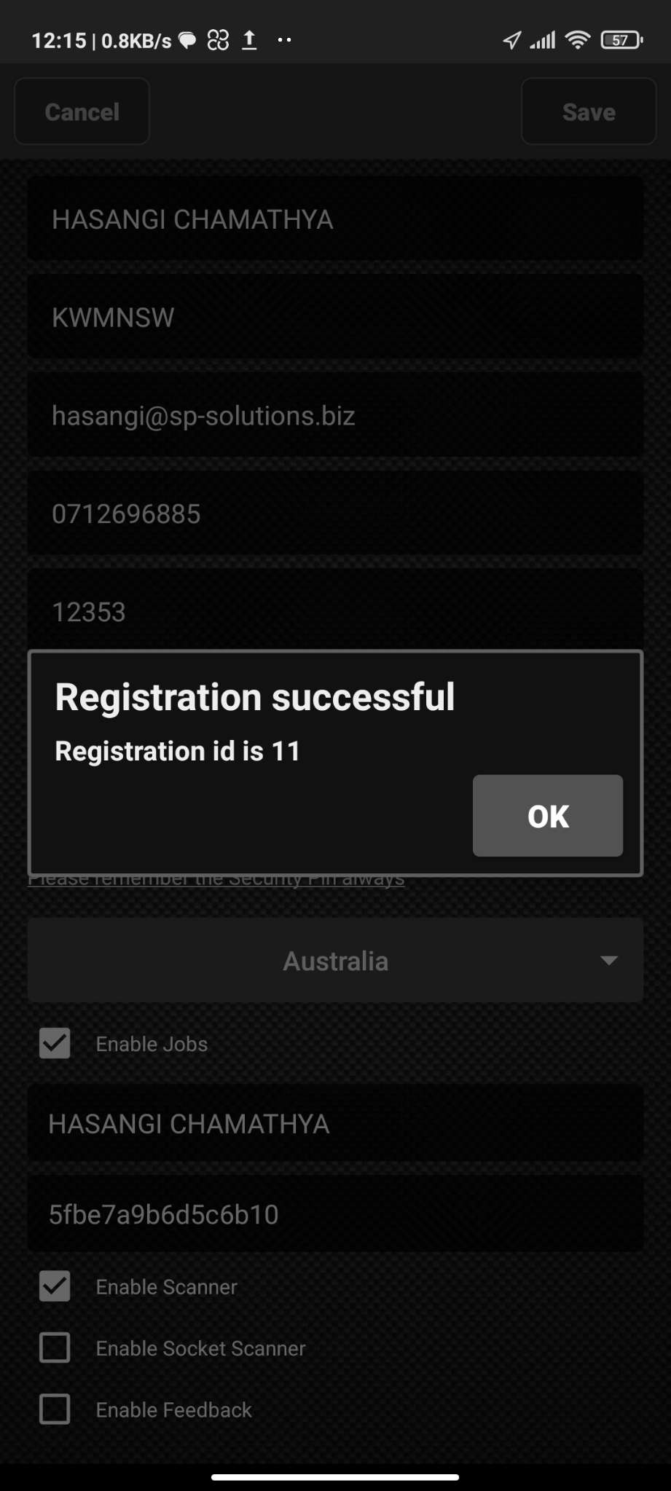

Then you will be taken to the login page of the app.

Click on the **Login** button and enter the **4 Digit Security Pin.**

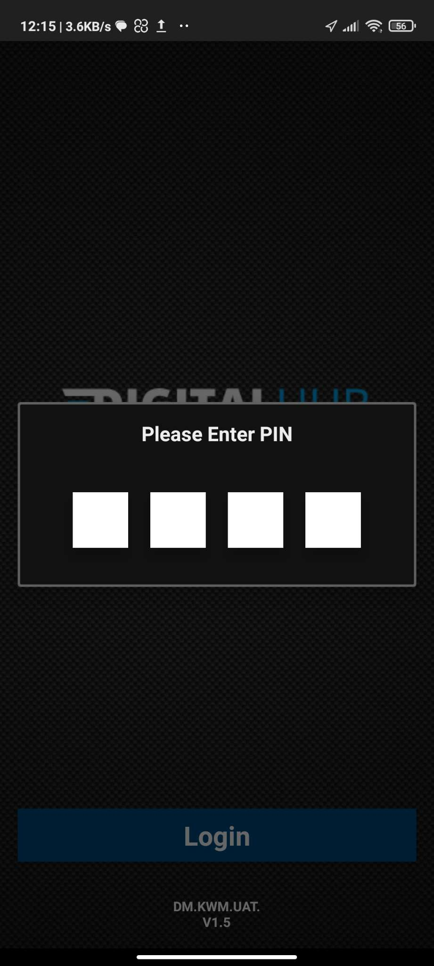

* 1. If you do not have a messenger driver account

Please contact the development & support team for a new driver account to be created.

# Data Set Up in the Application

Below settings must be set up before using the Digital Hub mobile application.

* 1. Client Settings

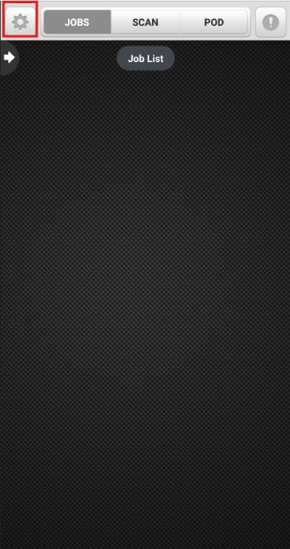 Click on the **Settings** icon.

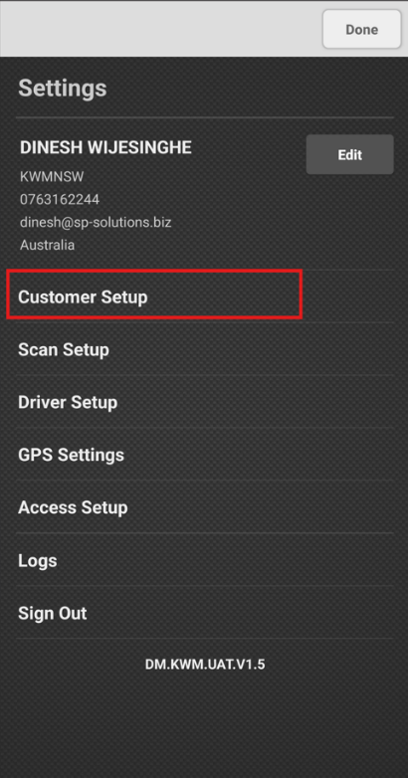 Then Click on **Customer Setup** button.

This will allow you to add the client companies.

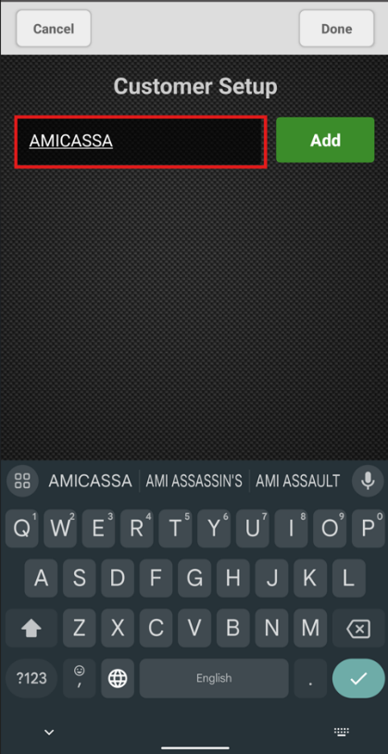 Enter the Name of the Client company in the text box.

And then click on **Add**.

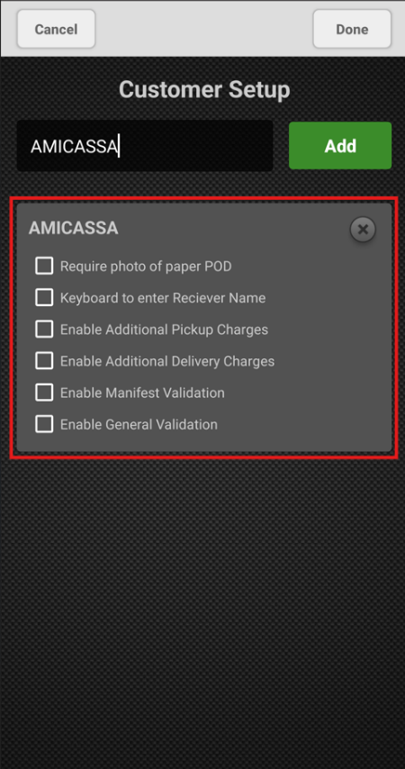 Once added, the company will be shown as in the screenshot.

Then click on the **Done** button.

* 1. Scan Setting

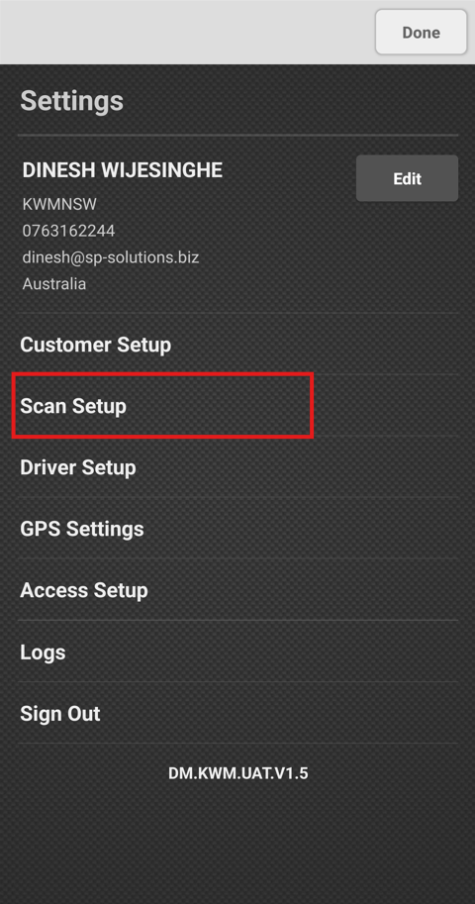 Click on the **Scan Setup** button.

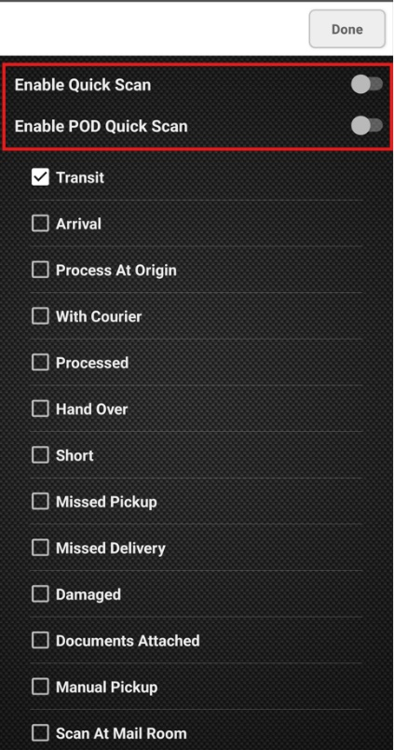 Enable the toggles **Quick Scan & POD Quick Scan**.

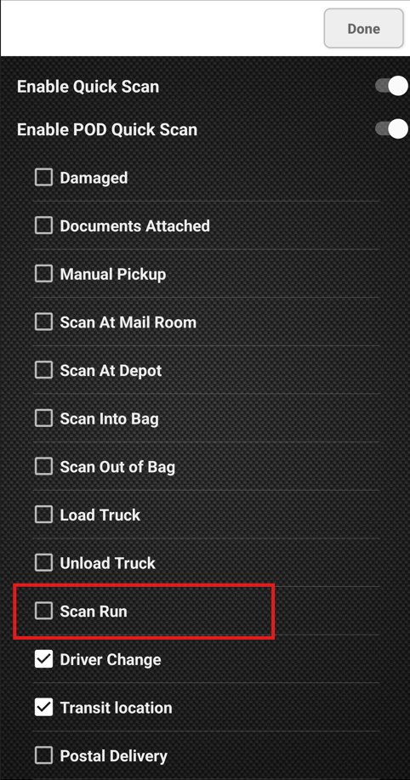 Click and **make sure Scan Run is ticked**.

Then click on **Done**.

# How to Process Booking that are Allocated to You

Open the **Digital Hub app** and go to **Jobs** page.

**Messenger Jobs allocated to you** will be displayed here.

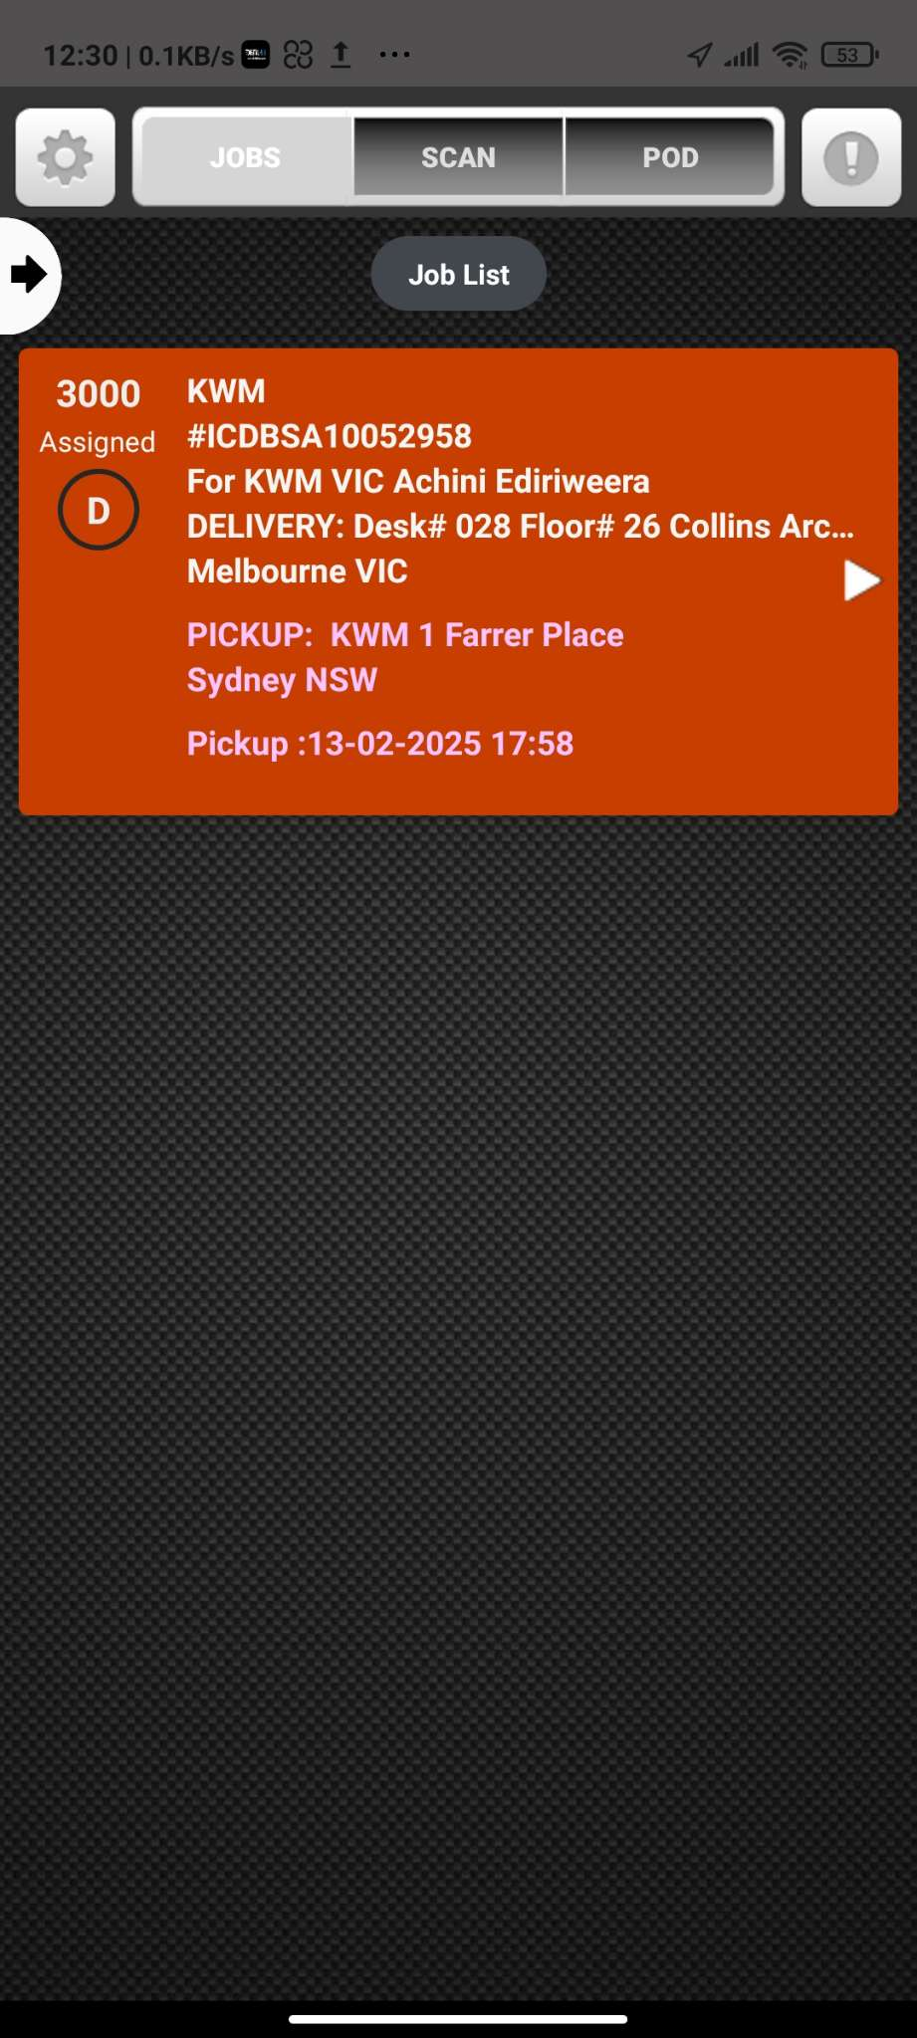

**Click on the Job.**

Then the booking will be opened.

Click on **Accept** to accept the Job.

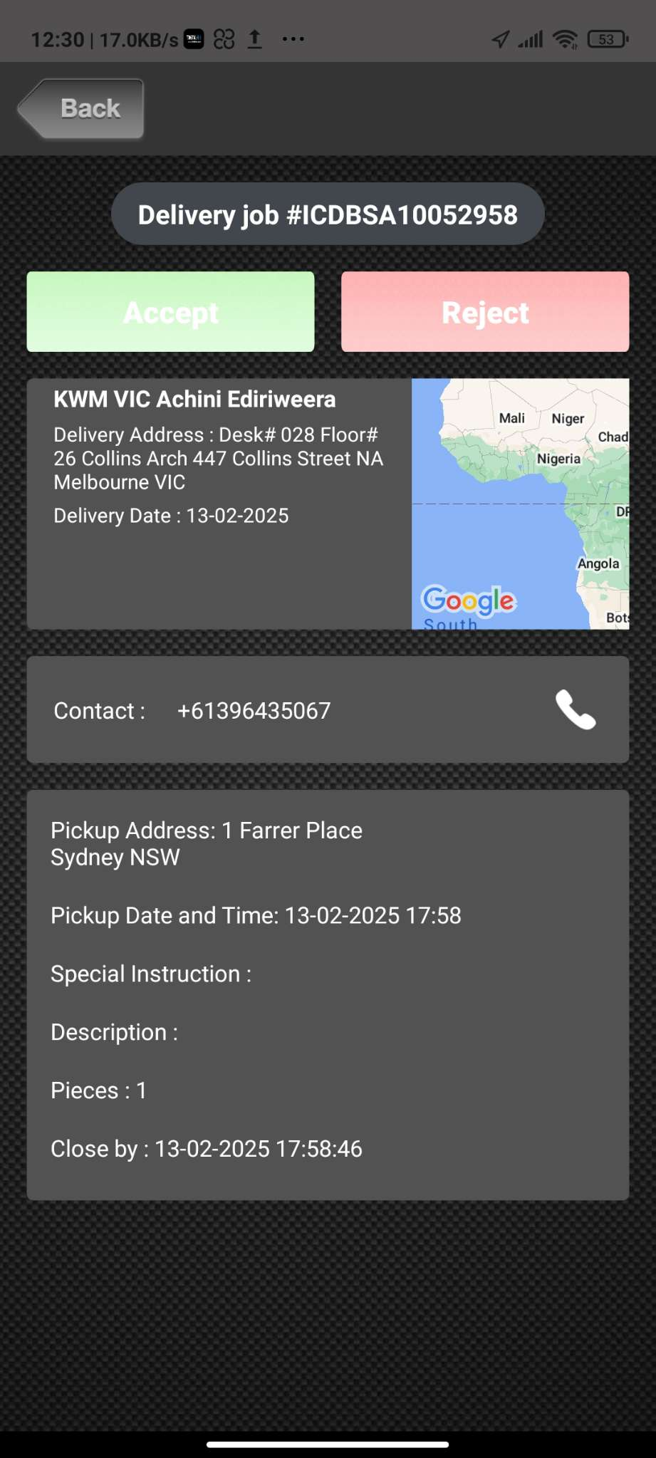

Then you will be redirected back to the **Jobs page**.

Click on the arrow on the booking you wish to mark as delivered.

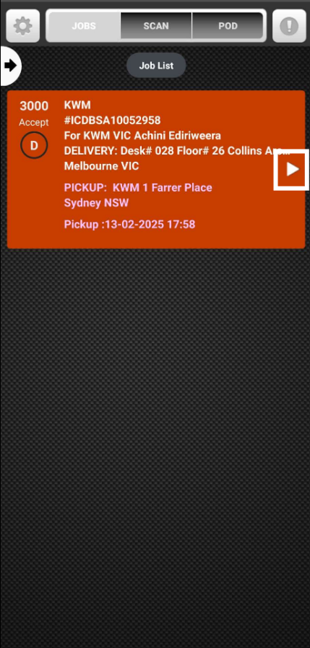

Then click on the **Deliver button**.

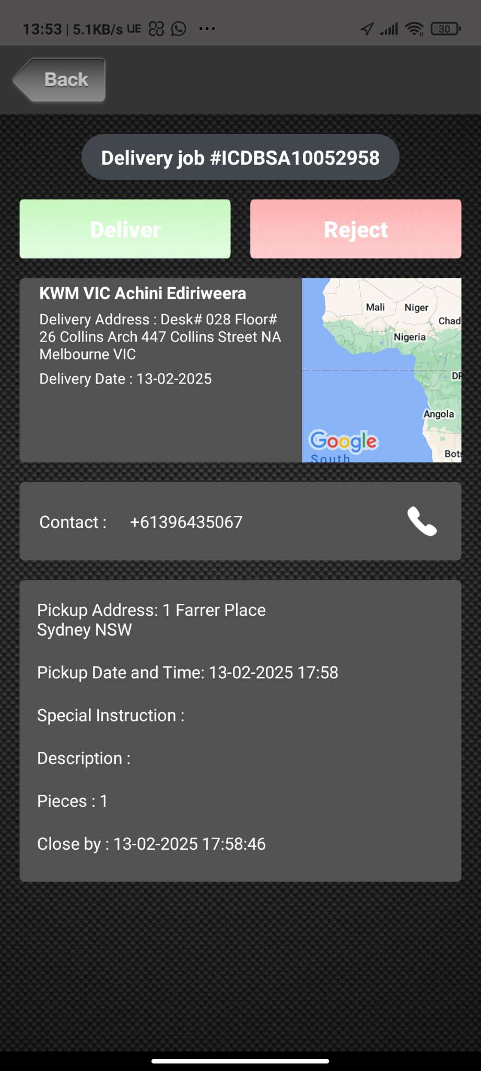

Then below interface will be shown.

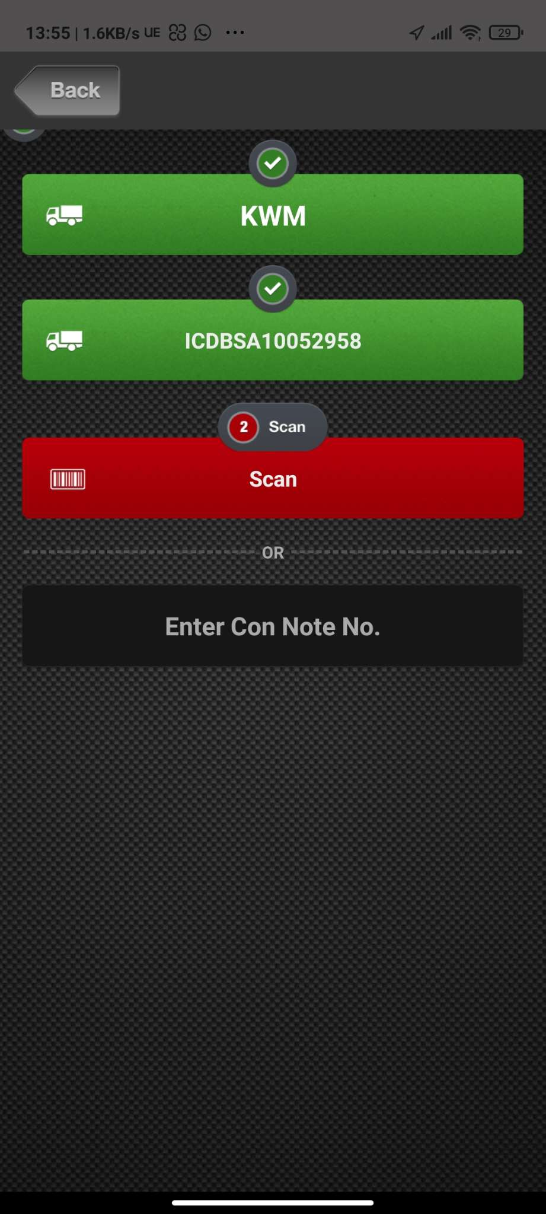

Then click on **Scan button and scan the** **Bar Code** on the package.

# How to Scan Run

If you wish to deliver a shipment by picking up from the mailroom follow below steps to **Scan Run** the packages.

Go to **Scan Page**.

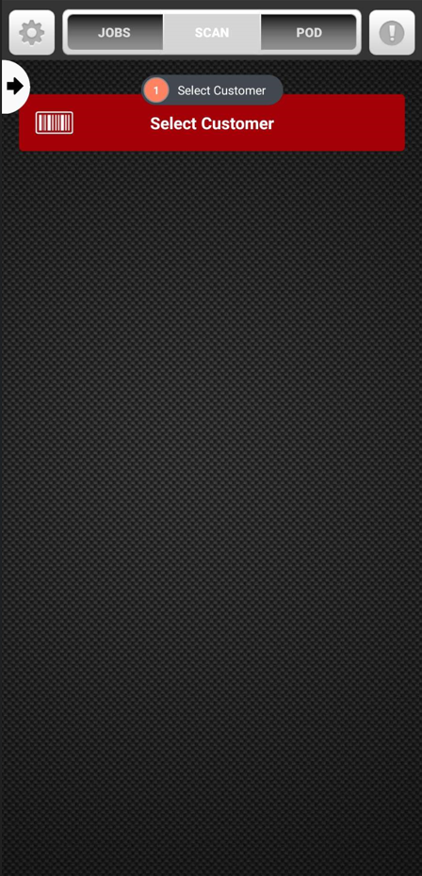 Click on **Select Customer** button

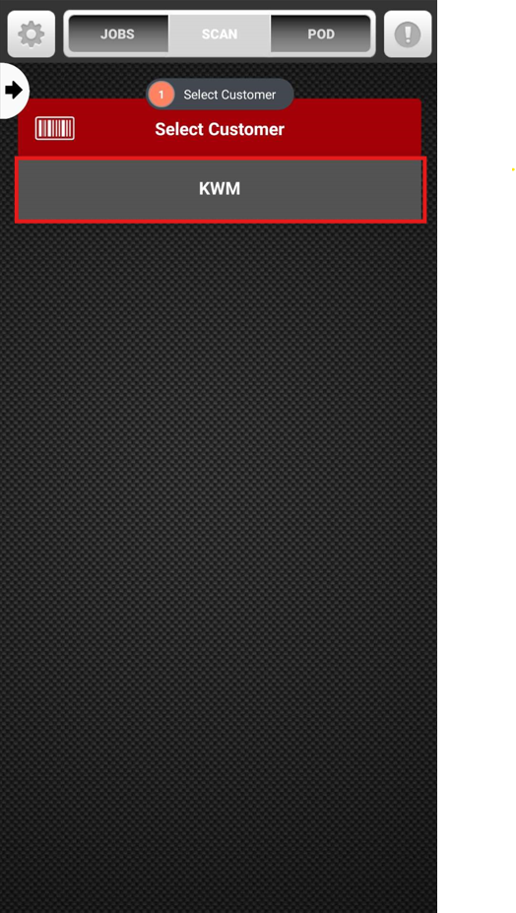 Then choose the client from the dropdown menu.

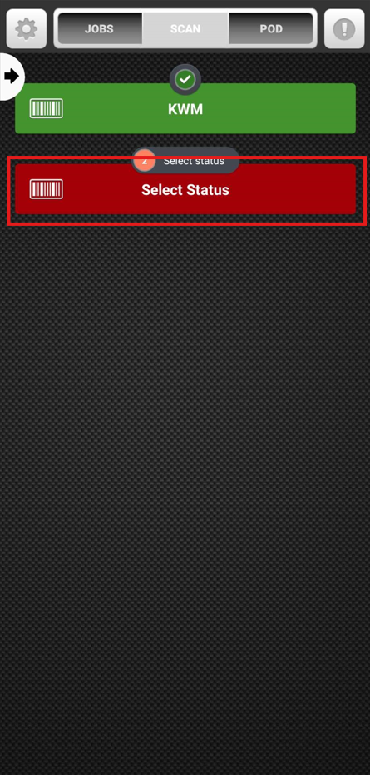 Then click on the **Select Status** button.

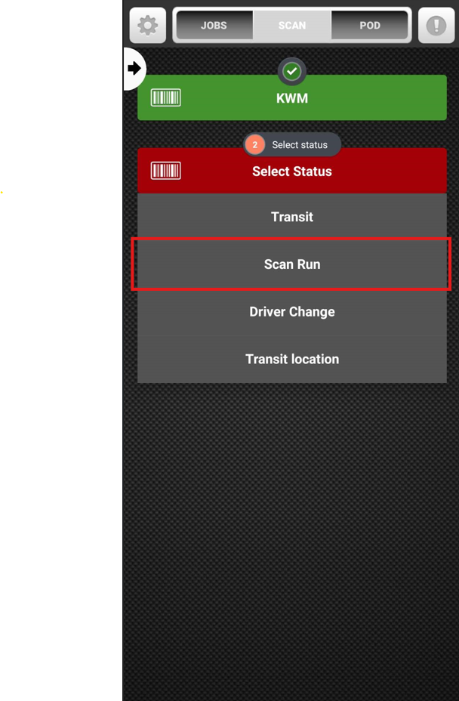 Then click on the status you want to update the booking.

Ideally, **Scan Run** wouldbe the first status update in a messenger booking.

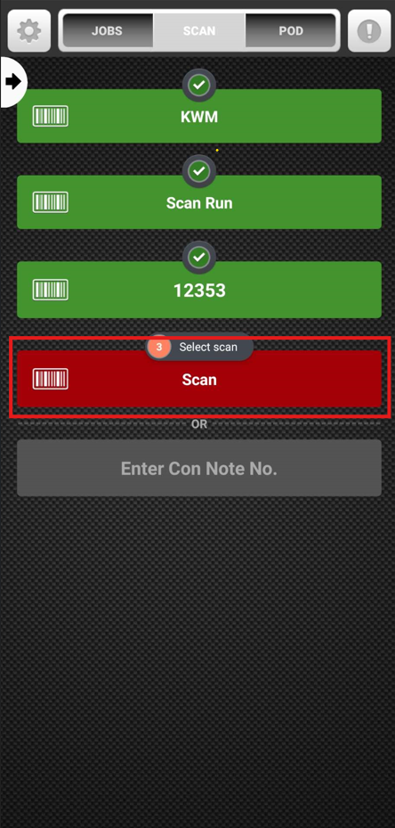 Then click on the **Scan** button to scan the bar code created for the package.

You have the option to scan **multiple items at once**, if you wish to do so, click on the **Scan** buttonagain toscan multiple packages.

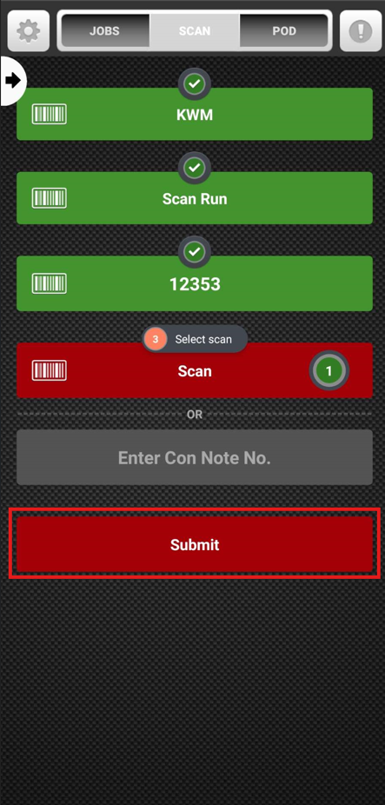 Then click on the **Submit** button to submit.

# How to mark POD (Proof of Delivery)

To mark the delivery, move to the POD page.

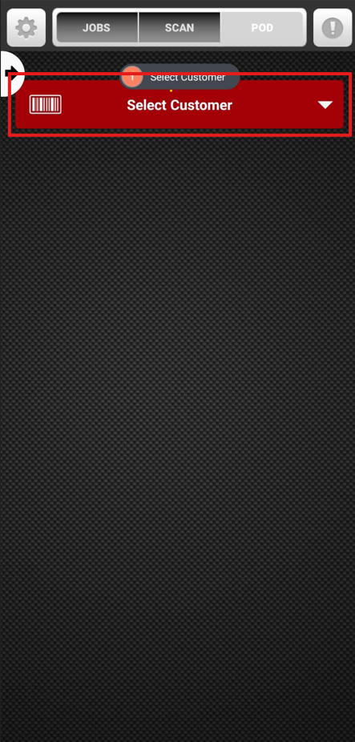 Then click on **Select Customer** button.

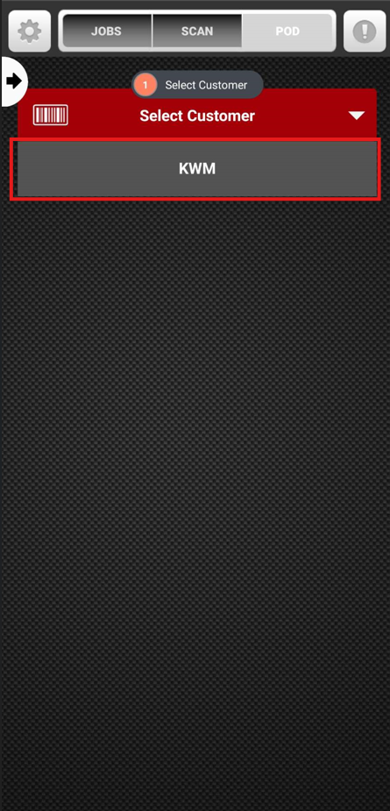 Then select the relevant company from the dropdown menu.

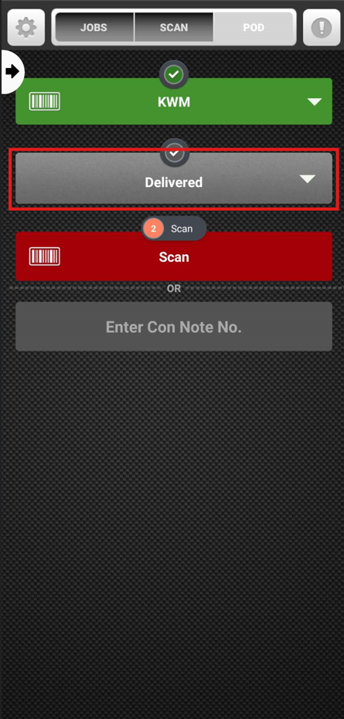 Then click on the **status** **button**.

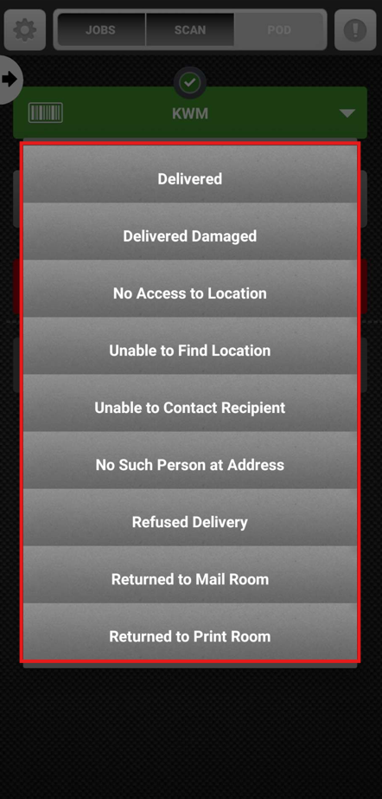 You can choose the status of your **choice from the dropdown menu.**

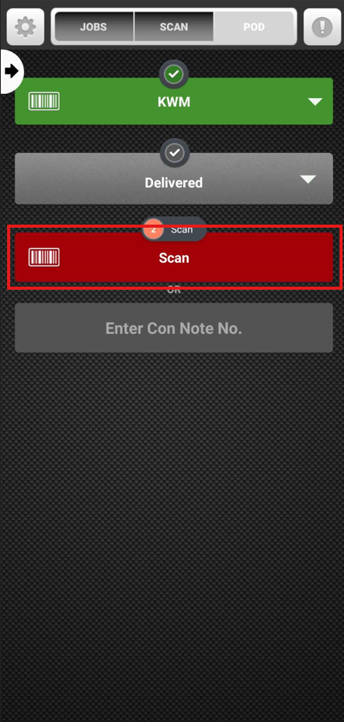 Then click on the **Scan button** to scan the bar code on the package which you wish to mark the POD( Proof of Delivery)

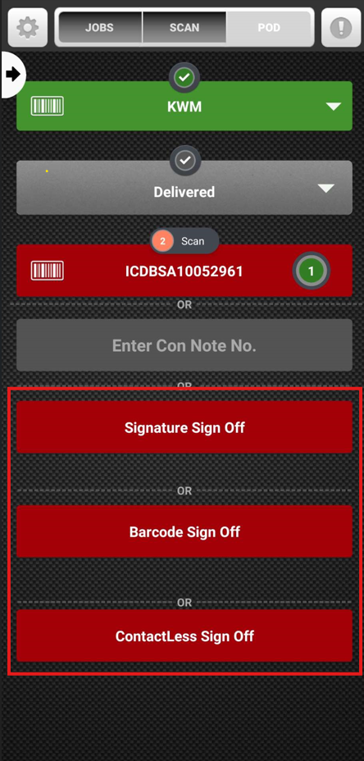 Once scanned you can mark the status by either one of the below options.

1. **Signature Sign off** ( Sign on glass)
   1. Mark the delivery with the signature
2. **Barcode Sign Off**
   1. Mark the delivery by scanning the barcode at client company
3. **Contactless Sign Off**
   1. Mark the delivery with a photo.

Once delivery has been marked successfully, you will receive a message **“ Transaction Successful”**

Then Click on **Done,** to finish the process.